Embassy of  The Kingdom of Morocco  Pretoria |  | 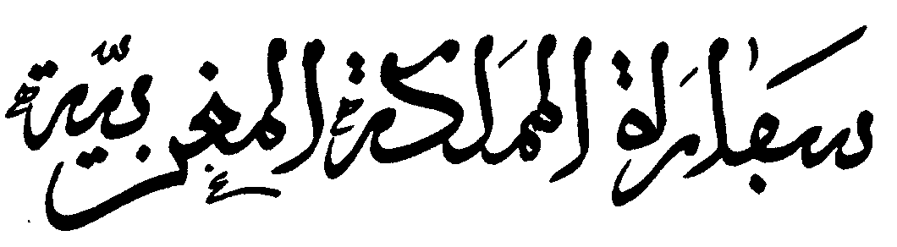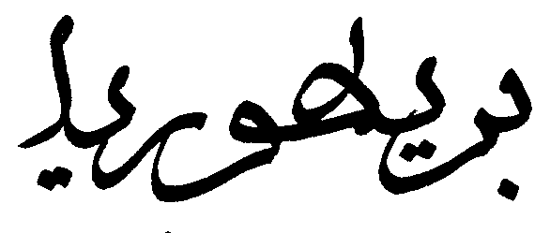

Visa Application Form

_____________________________

Photo

1. | First Name(s) :
 | ………………………………………………………………………………………………………………………………
2
2. | Family Name(s) :
 | ……………………………………………………………………………………………………………………………….
3. | Date of Birth : |  |  | 4. Green Card Number :
 |  |  | ……/……/…….. | ………………………………………………………………………
 |  |  |  | ( For minors write mention « minors »
555
5. Place and Country of birth………………………………………………………………………
6. | Current Nationality : |  |  | 7. Original Nationality (Nationality of
 |  |  |  | birth) :
 | ……………………………………………………………………… |  |  | ………………………………………………………………………
8. | Sex : |  |  | 9. Marital situation :
□ | Male | □ | Female | □ Single | □ Married | □
 |  |  |  | Separated
 |  |  |  | □ Divorced | □ Widow
 |  |  |  | □ Other:
 |  |  |  | ……………………………………………………
10. Father’s name and Family Name |  |  |  | 11. Mother’s Name and Family Name :
……………………………………………………………………………... |  |  |  | ………………………………………………………………………..

Cadre réservé aux services
del'Ambassadeou du
Consulat

Date d’introduction de la demande : . . / . . / . . . .

…………………………..

Responsable du dossier :

……………………………….

Visa :

□ Refusé
□ Accordé
□ Annulé

Type et catégorie du visa :

……. / ……..

Nombred'entrées :

□ 1 □ 2 □ Multiples

12. | Type of Passport : |  |  |  | □ |  | Ordinary Passport |  |  |  |  | □ Diplomatic Passport
□ Service Passport or equivalent |  |  |  |  |  |  |  | □ Travel document for refugier or apatried
□ |  | Other
…………………………………………………………………………………………………………………………..
13. | Passport Number : |  |  |  |  |  |  |  |  | 14. Issued by :
……………………………………………………………………..
 | Serial Number : |  |  |  |  |  |  |  |  | ……………………………………………………………………..
 | ……………………………………………………………………..
15. | Date of issue |  |  |  | . . / . . / . . . . |  |  |  |  | 16. Valid until : |  |  |  | . . / . . / . . . .
17. | Profession :
 |  |  | ……………………………………………………………………………………………………………………………
18. | Purpose of Travel :
 |  |  |  | □ | Tourism |  |  | □ Affairs |  |  | □ Family visit |  |  |  | □ Culture/ Sport
□ |  | Official visit |  |  | □ Medical Purpose |  |  |  |  | □ Studies |  |  | □ | Other ( Precise):
 | ……………………………………………………………………………………………………………………………………
19. | Type of visa |  |  | 20. Number of entries : |  |  |  |  |  |  |  |  | 21. Duration of stay :
□ Long validity |  |  |  | □ | Single entry |  |  |  |  |  |  |  | Number of days:.…….
□ Short validity |  |  |  | □ | Two entries
□ Transit |  |  |  | □ | Multiple entries
22. | Arrival date : |  |  |  |  | 23. Border of entry or transit |  |  |  |  |  |  | 24. Mean of transport :
 |  | . . / . . / . . . . |  |  |  | route
 |  |  |  |  |  | …………………………………………………….. |  |  |  |  |  |  | ………………………………………………
25.Previous visas :
 |  | Date |  |  | Number |  |  | Place of issue |  |  |  |  |  |  | Duration
1.
2.
3.
26. | In case of transit, have you un entry permit to entry to Final country
 |  | □ | No | □ Yes
Country of destination: …………………………………………………………………………..
 |  |  |  |  |  |  |  | Valid until: |  |  |  | . . / . . / . . . .
 |  |  |  |  |  |  |  | Delivered by …………………….

Valabledu : . . / . | . / . . . .
Au : . . / . . | / . . . .

Motif :(En cas de Refus ou d’Annulation)

......................................................

………………………………………

27. Host or Host company :

(If not, indicate name or a temporary adress in Morocco)

Name: ………………………………………………………………………………………………………..

Address:………………………………………………………………………………………………………..

 | ………………………………………………………………………………………………………..
Telephone Number: |  | Fax :
……………………………………. |  | ……………………………….
Email | :
……………………………………………………………

28. Who is paying for your travel and your needs during your stay ?

□ My Self □ Host(s) □ Host company (Indicate the names and themodalities and present corresponding documentation)

……………………………………………………………………………………………………….
……………………………………………………………………………………………………….

29. Financial Means used during your stay :

Moyens de financement utilisés au cours du séjour :

□ Money (Cash) □ Traveller Cheques □ Credit Card □ Accommodation

- Others: ……………………………………………………………………..

- Travel Insurance and/or Medical Insurance – Valid until : . . / . . / . . . .

30. Children (individual application for each passport) ………………………..

Family Name First Name Date of birth
1-
2-

3-

I declare that all information I advanced is correct and complete. I am conscious of the fact that any false declaration will lead to the rejection of application or the annulment of the the visa if already issued and may lead to legal proceedings according to the regulations in force in Morocco.

Note :

- In addition to your valid passport and visa, you should be able during your passage through the Moroccan frontier to present all documents that may justify your return and your stay, your subsistence means, insurance statement, etc
- Entry to the Moroccan territory may be refused to the alien who does not fulfil all these requirements.

Providing all the required documents does not necessarily open right to visa.

َ
َ 31.َApplicant’s address : | 32. | Phone :
……………………………………………….. | ………………………………………..
َ
33. City/State :……………………… | 34. | Signature :………………………

